Pretty Good Precision!
Dave Lewis r-Labs LLC
Students in the Discovery Charter School 3D Design and printing class continue to advance their skills as designers and Makers. One of the biggest challenges in any production environment is making sure that two separate parts fit together correctly. Many engineers remember the problem with the US and Russian spacecraft when there was an issue with the locking rings.
Ben, who has been in the class for a couple of semesters, wanted to make his own version of the Star Trek ™ Borg Cube that lit up from within like the one of the TV show.
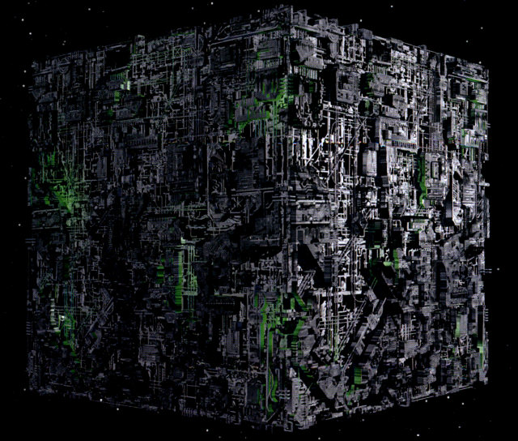
Ben decided that an interior core of translucent material with an LED and an exterior shell that precisely fitted the core and had cutouts to let light through was the way to go. The core was easy, but the shell with asymmetric shapes and overhangs was a lot more challenging and the first several attempts ended up as “birds nests”.
This weekend Ben achieved a near perfect fit for the two pieces of his Borg Cube. The interior was printed in Translucent PLA on the 3D Touch printer while the shell was printed on a Cube II in black PLA.
The core was pretty simple as a shape and Ben designed in space for the Battery as well as two spaces for the LEDs.
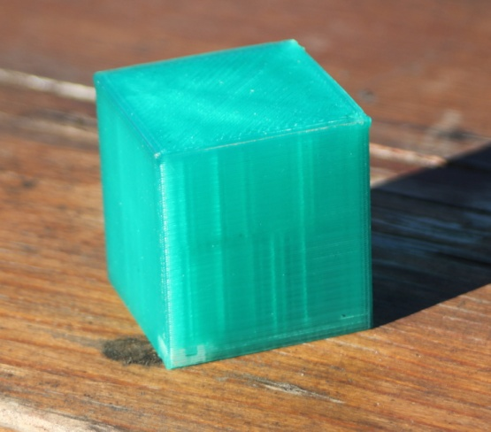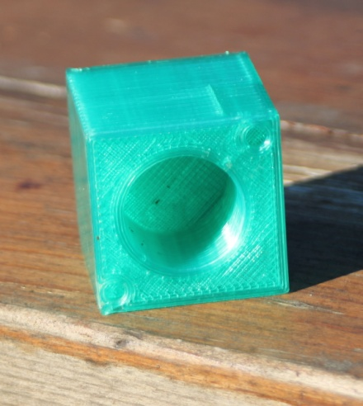
Printed in Green Translucent PLA on a 3D Touch
The shell was a lot harder and we spent a lot of time ensuring that the two pieces would, in theory, be a good fit. There is always the challenge of using two different materials with different engineering properties and then printing on two different printers.

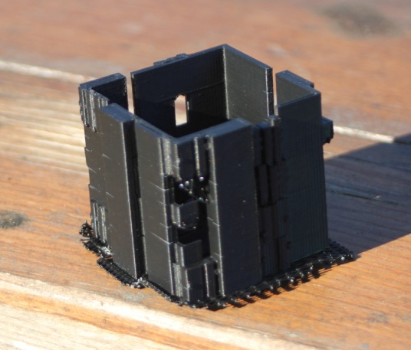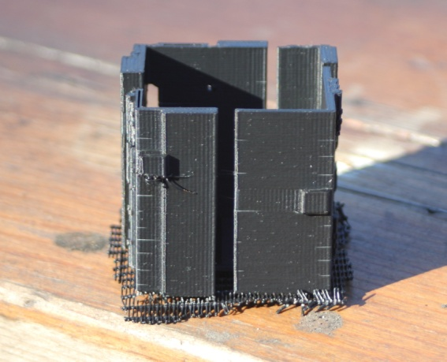
The Shell (on a raft) Printed in Black PLA on a Cube II

The shell came off the printer in pretty clean shape with only a minor thread or tow to take off (and the raft of course). The big question, would they dock?

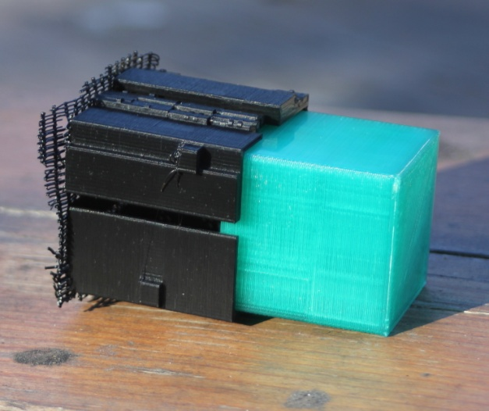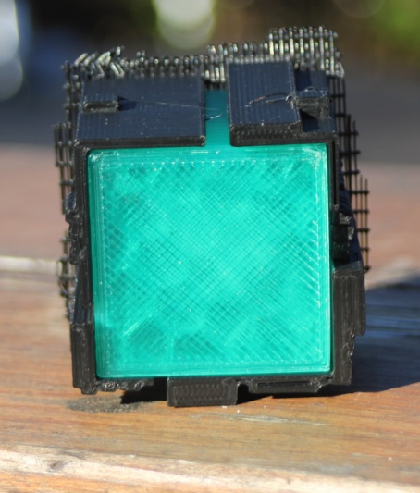
YES!!!
The fit of the first complete shell to the core was excellent with less than 10 microns in spacing between the core and the two pieces.
While not as elaborate as the models used in Star Trek, it looks pretty great and took Ben through a real lesson in persistence.
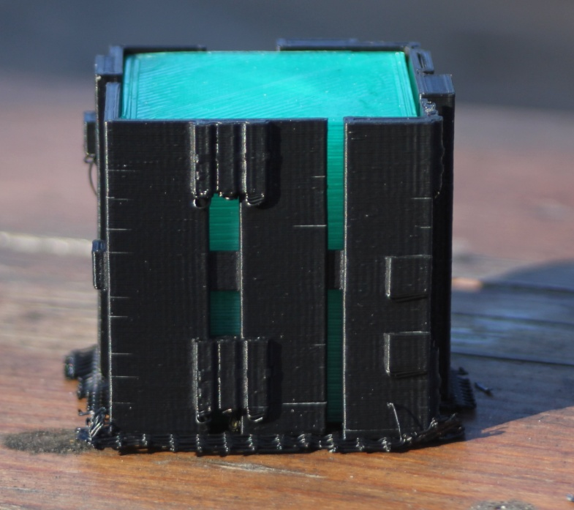
Students are Assimilating this Technology!

For More information contact Dave Lewis at Rileys_Dad@yahoo.com

